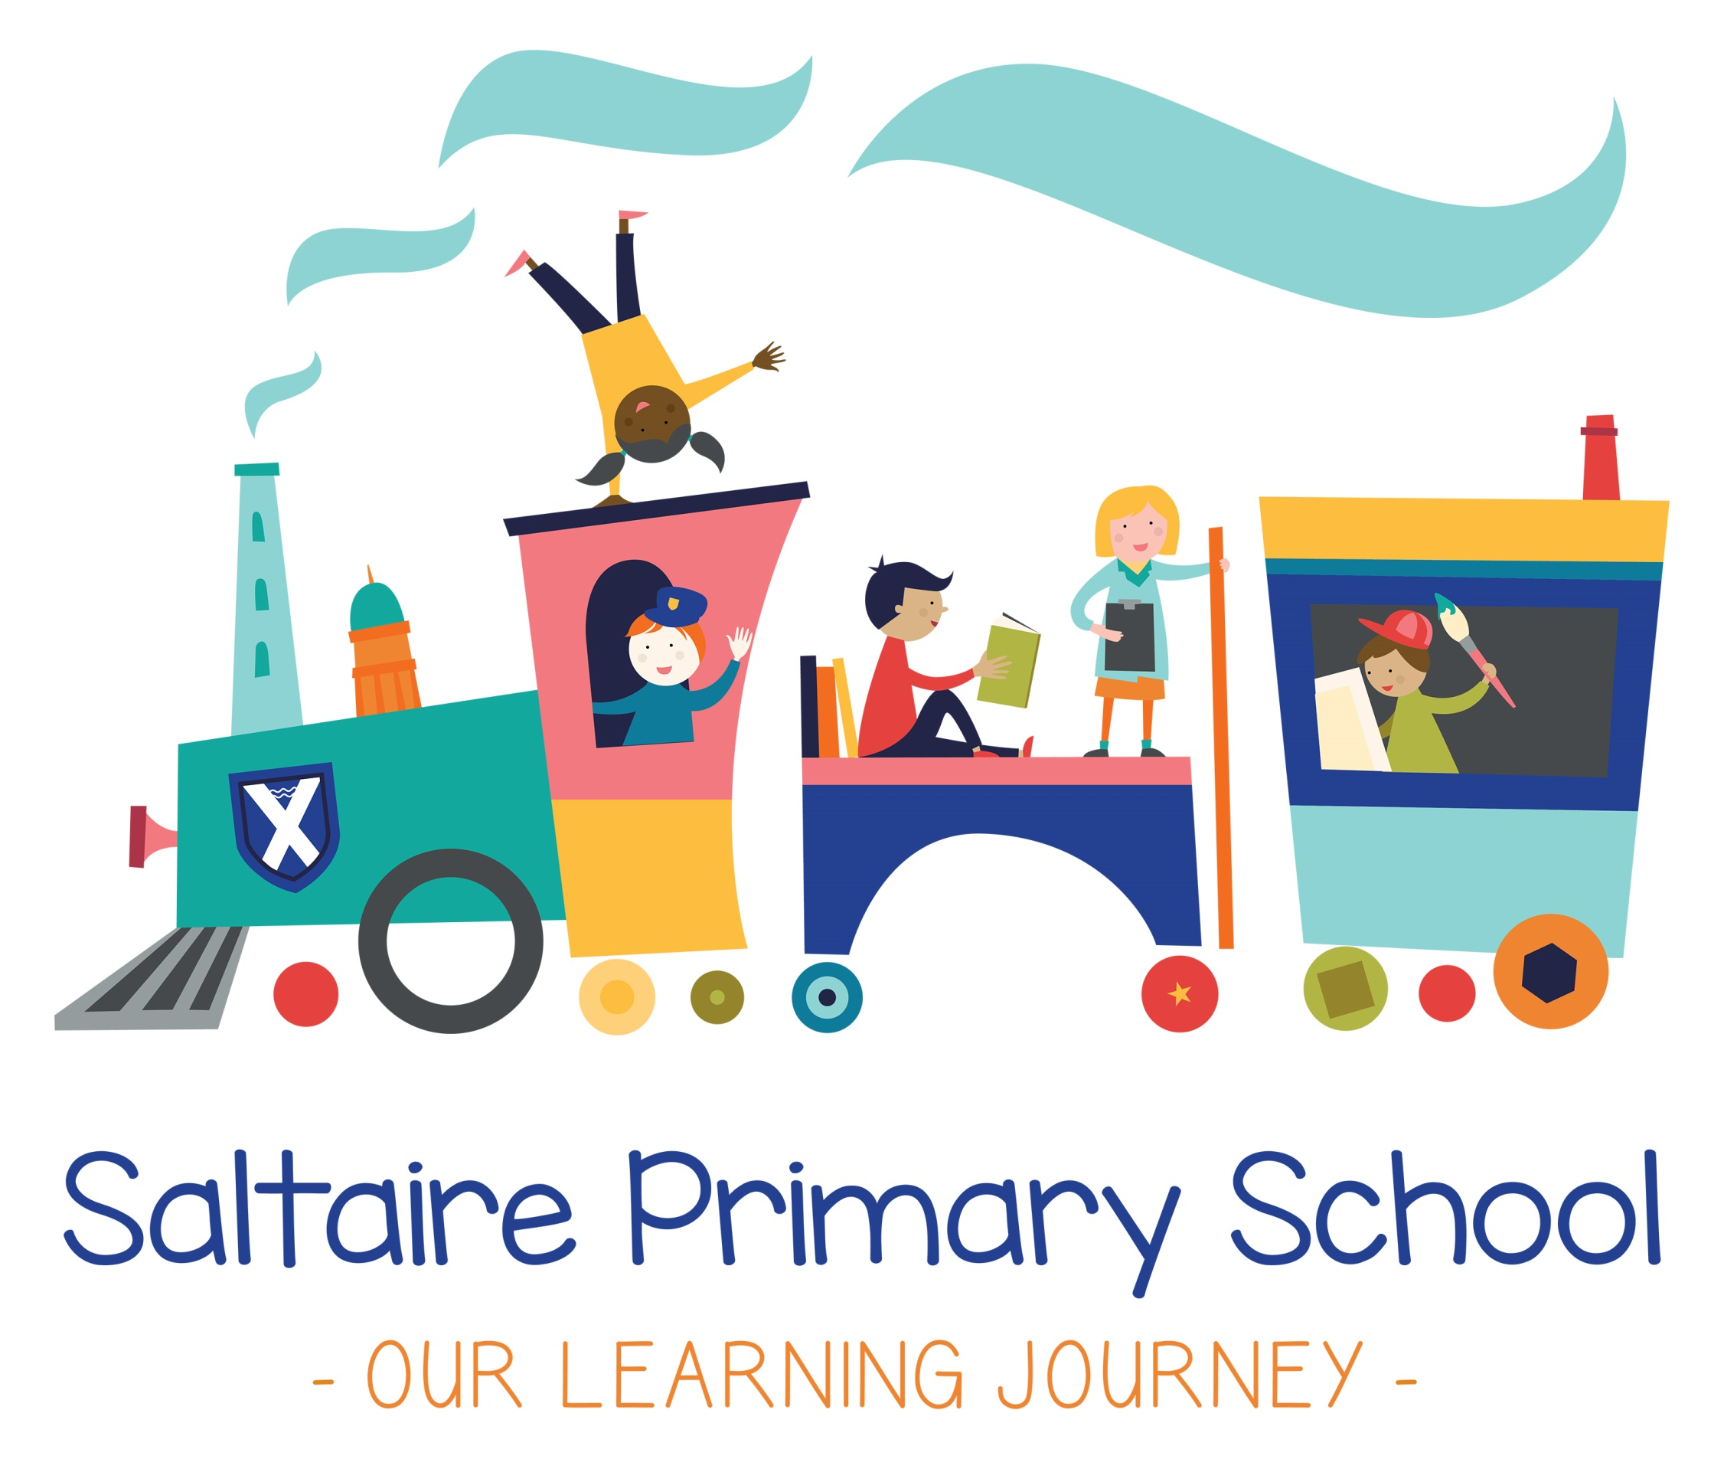
Saltaire Primary School

Primary PE Policy

Contents:

Rationale
- Attainment and progression targets
- Subject content

Rationale

Saltaire Primary School believes that a high-quality physical education curriculum inspires our pupils to excel and succeed in physically demanding activities and competitive sports.
We wish to support our pupils’ health and fitness and provide them with opportunities to become physically confident. It is our aim to inspire our pupils to be involved in sport and other activities to help build character and embed British values such as good sportsmanship and respect. We recognise the importance of competitive sport, and provide regular opportunities for our children to participate in these events.

Aims:
The national curriculum for physical education aims to ensure all pupils:
- Develop competence to excel in various physical activities.
- Are physically active for sustained periods of time.
- Engage in healthy, competitive sports and activities.
- Lead healthy, active lifestyles.
In addition to this, our schools’ shared aims are that:
- Learning is fun and we enjoy what we do.
- Enthusiasm is nurtured for teaching and learning

Provision of physical education:
The school aims to provide all pupils with two of hours of high quality Physical Education, per week within all classes. This is delivered through two lessons of 1 hour duration, one of which may be delivered by a qualified games instructor, both in conjunction with the class teacher. Units of work are appropriately linked. Each class is timetabled so that they can access the hall for the duration of the unit that they are studying. The outdoor play area is available to support all Physical Education learning & activity. Where possible, we work with other providers from the community to further support our PE provision and enrich children’s experiences. In addition, we provide an extra-curricular timetable of varied activities which provide children with wider opportunities for sport.

Equal Opportunities:
All children should be provided with equal opportunities to participate in a curriculum in which there are no barriers to access based on race, sex, culture or ability. PE lessons should aim to provide quality experiences, which challenge children of all abilities.

Health and Safety:
Health and Safety issues in P.E. include the following guidelines to teachers:
- Check that equipment is safe and suitable for use on the particular day you use it. The specialist equipment is checked annually by an external company.
- Ensure there is adequate supervision and that discipline is good.
- Pupils should be taught to understand the need for safe practice in physical education and how to achieve this.
- Pupils should be set only work that they are sufficiently competent to cope with.
- Clothing – suitable, so presents no hazard, bare feet indoors (unless games played which might injure bare feet), nothing to get caught, hair tied back, jewellery/watches removed.
- Expectation that the teacher will dress appropriately for all PE lessons to avoid injury and promote good practice.
Please see the school Health and Safety Policy for further information.

Progression and Continuity:
At Saltaire Primary School we plan the activities in PE so that they build on the children’s prior learning. While we give children of all abilities the opportunity to develop their skills, knowledge and understanding, we also plan progression into the scheme of work, so that there is an increasing challenge for the children as they move up through school (see attached document). Individual learners are able to make progress in the acquisition of concepts, knowledge and skills at the rate most appropriate to their ability and stage of development.

Feedback to pupils:
Feedback to pupils is through discussion. It is important that learners are involved in the assessment of their work as this helps them to understand their own strengths, needs and future targets for development. We encourage children to make judgements about how they can improve their work and their peers’ work. Children are regularly given the opportunity to edit and make improvements to their work.

PE Spend:
The PE funding ensures that we can put strategies in place so that there are opportunities for all children to be challenged and supported in accessing school sport. Pe teaches our children to work together, enjoy and value competitive activities and develop their understanding of the importance of PE in ensuring their long-term health and well-being. See PE Spend document for a comprehensive breakdown of the PE budget.

Signed by
Headteacher Date:

Chair of Governors Date:

PE Governor Date:

Attainment targets
By the end of each key stage, pupils are expected to know, understand, and apply the matters, skills, and processes specified in the appropriate programme of study. We monitor Key Performance Indicators for each year group to assist assessment and progress.

Subject content
  - Key stage 1
Pupils are to develop fundamental movement skills, become progressively capable and confident, and access various opportunities to extend their agility, balance and coordination, individually and with their peers. Engaging in competitive and co-operative physical activities in a range of increasingly challenging situations is vital to their development.
Pupils should be taught to:
- Master basic movement and apply these in a range of activities including:
  - Running.
  - Jumping.
  - Throwing.
  - Catching.
  - Developing balance, agility, and coordination.
- Partcipate in team games and develop simple tactics for attacking and defending.
- Perform dances using simple movement patterns.
  - Key stage 2
Pupils should continue to apply and develop various skills, learning how to use them differently, and make actions and sequences out of movement.
Pupils should enjoy communicating, collaborating and competing with others, and develop an understanding of how to recognise, evaluate, and improve their techniques.
Pupils should be taught to:
- Run, jump, throw and catch in isolation and together.
- Play competitive games, modified where appropriate, and apply basic principles to attack and defend.
- Develop flexibility, strength, technique, control and balance.
- Perform dances using various movements.
- Take part in outdoor and adventurous activities, both individually and as a team.
- Compare their indiviudal performances with previous ones to demonstrate improvement so they can achieve to the best of their ability.
Swimming and water safety
All schools must provide swimming instruction in key stage 1 or 2.
In particular, pupils should be taught to:
- Swim competently, confidently and proficiently over a distance of at least 25 metres.
- Use a range of strokes effectively.
- Perform safe self-rescue in different water-based situations.

