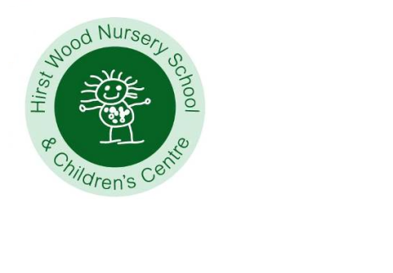Do you need before and after

School childcare?

can offer quality provision every morning Monday to Friday from 8.00 to 9.00 a.m. at a cost of £5.00 per session and

Monday to Thursday evening from

3.15 to 6.00 p.m. at £11.00 per session plus Friday to 5.30pm at £10.00



Friendly, highly qualified staff providing a quality experience for children aged 3 to Year 2.

Please call in, telephone or email for further details.

Hirst Wood Nursery School & Children’s Centre

Clarence Road, Saltaire, Shipley, BD18 4NJ

Tel. 01274 584368

**www.hirstwoodnscc.co.uk**