Policy Approval Date | September 2020
Policy Review Date | October 2020
Committee | Full Governors
Statutory Policy | No
Policy on Website | Yes

behaviour policy
coronavirus addendum
september 2020
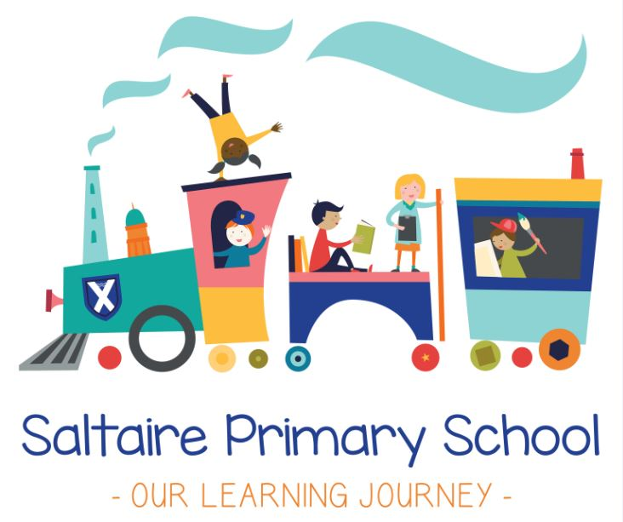
Saltaire Primary School

Behaviour Policy Coronavirus Addendum
September 2020

Contents
1. Scope 3
2. Expectations for pupils in school 3
3. Expectations for pupils at home 4
4. Monitoring arrangements 5
5. Links with other policies 5

1. Scope
This addendum applies until further notice.
It sets out changes and exceptions to our normal behaviour policy. Pupils, parents and staff should continue to follow our normal behaviour policy with respect to anything not covered in this addendum.
We may need to amend or add to this addendum as circumstances or official guidance changes. We will communicate any changes to staff, parents and pupils.

2. Expectations for pupils in school
2.1 New expectations
When pupils are in school, we expect them to follow all of the expectations set out below to keep themselves and the rest of the school community safe.
Staff will be familiar with these expectations and make sure they are followed consistently.
Parents should also read the expectations and ensure that their children follow the new procedures that have been put in place. Parents should contact the headteacher if they think their child might not be able to comply with some or all of the expectations, so we can consider alternative arrangements with them and support them to integrate back into school life.
Reasonable adjustments can be made for children who present with more challenging behaviour. This will be detailed in a behaviour plan devised by key members of staff and in consultation with parents.
Arriving at and leaving school
- Children will enter the school grounds using the one-way system. Younger children will be accompanied by an adult.
- Children should move quickly and sensibly as they make their way into and around the building, being careful to walk (The Saltaire Walk) rather than run
- If walking home by themselves, children should leave the school site via one of the identified gates and make their way home as agreed with the parent or carer
- Children should not congregate on the school site or at the entrances and exits at the beginning and end of the day

Hygiene, such as handwashing and sanitising
- Children should wash their hands regularly using soap and water, especially after using the toilets
- Children may also use sanitiser when asked to do so by an adult who will supervise the use of sanitiser
Staying in your bubbles
- Children should only socialise with other children who are in their bubble. In most year groups (Year 2 upwards) this will usually include children from your own class (not the other class).
- Children should only socialise with children from other bubbles when given permission by a member of staff.
- Children should avoid hugging and touching other children whenever possible, even within their own bubbles. Children should not hug or touch children from other bubbles.
- Children should only play outside in the areas where teachers and other adults tell them to. They should not go into a different part of the playground unless given permission by an adult.
- When moving around outside, children should go straight to their provided area. They should not cross over with other groups or stop to have conversations with children from other year groups.
Moving around the school
- When children are in the Aire Building (Key Stage 2), they must use the one-way (clockwise) system at all times.
- They should use the appropriate staircase to go up and down stairs.
- Children should use the Saltaire Walk at all times to move around inside the building.
- Children should maintain a distance of at least one metre from other people in the building, especially when they are not in their bubble.
- Children should be careful to give others space in the building. This might mean stopping or changing direction to avoid coming into contact with others who are not in your bubble.
Feeling unwell
- Children should try to sneeze or cough into a tissue when possible and dispose of their tissue in the bins provided (‘catch it, bin it, kill it’).
- If they do not have a tissue, children should cough or sneeze into their elbow.
- Children should try to avoid touching their mouth, nose and eyes with hands.
- Children should tell an adult if they are feeling unwell.
- Children should be careful not to cough or spit at other people.
Use of toilets
- Children should use the toilets they are told to use by adults.
- When going to the toilet, children must be sensible at all times. They must not behave in a way which puts themselves or others at risk while using the toilet.
- Children will try their very best to keep the toilets clean and safe.
- Children should use the toilets as quickly as possible, wash their hands then leave. They should not wait for or talk to other children while they are inside the toilets.

2.2 Rewards and sanctions for following rules
We will continue to follow our school’s behaviour policy to provide rewards and sanctions for children who follow our behaviour expectations.
We recognise that children sometimes do things accidentally and will investigate incidents to work out what has happened. However, if a child has purposefully behaved in a negative way or put other children at risk, we will follow our sanction procedures as set out in our usual behaviour policy.

3. Expectations for pupils at home
3.1 Remote learning rules
If pupils are not in school, we expect them to follow the expectations set out below.
Parents should also read these expectations and ensure their children follow them. Parents should contact Chris Evans, Deputy Headteacher if they think their child might not be able to comply with some or all of the rules, so we can consider alternative arrangements with them and support them with their learning.
- Be contactable during required times – although take into account that pupils may not always be in front of a device the entire time
- Complete work to the timescales set by teachers
- Seek help if they need it, from teachers or teaching assistants
- Alert teachers if they’re not able to complete work
- Use proper online conduct, such as using appropriate language in messages
3.2 Dealing with problems
If there are any problems with pupils adhering to expectations around remote learning, including if they don’t engage with the remote learning set for them, we will:
- Call parents and carers to discuss any issues which might be faced
- Provide additional resources if it will help a child to access work more easily

4. Monitoring arrangements
We will review this policy as guidance from the local authority or Department for Education is updated, and as a minimum every month by Rob Whitehead, Headteacher. At every review, it will be approved by the full governing board.

5. Links with other policies
This policy links to the following policies and procedures:
Child protection policy
Code of conduct
Behaviour policy
Health and safety policy
Online safety policy
Attendance policy

