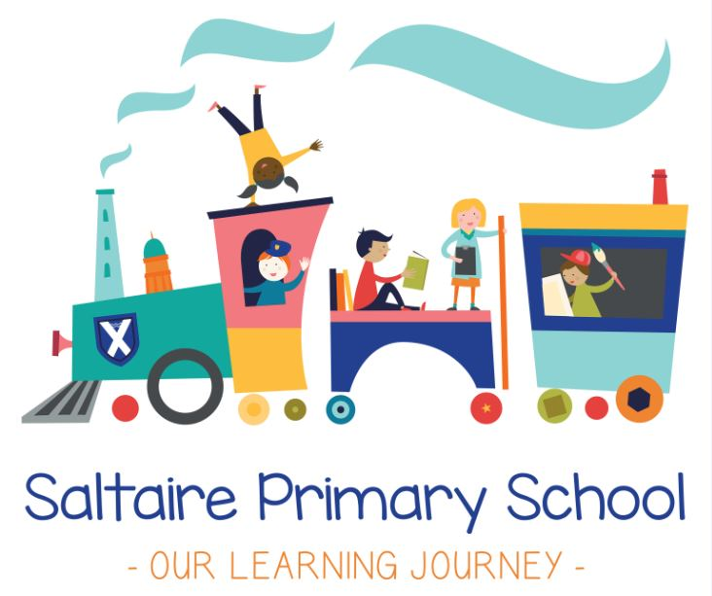

Positive Behaviour Guide

Saltaire Primary School
Positive Behaviour Guide
At Saltaire Primary School, we work hard to ensure there is a culture of good behaviour in all aspects of the school day, recognising that there are different times during the day when our behaviour might be different according to circumstances, in particular:
- During lessons
- When moving around the school
- At playtime
- Throughout lunchtime
- During assemblies
- In PE lessons
- On educational visits
This guide outlines our expectations throughout the school day.
To promote good behaviour in school, we have three golden rules to help children in their approach to school life. These are:
We treat each other with RESPECT
We show KINDNESS
We ensure SAFETY for everyone

Behaviour for Learning
Children at Saltaire Primary School love learning and demonstrate exceptionally positive attitudes during lessons. So this is maintained, we ensure that:
- Learning is interesting and purposeful so that children engage meaningfully in lesson content;
- Teachers and support staff set clear and high expectations for learning, promoted through a culture of mutual respect and politeness;
- There are opportunities to move around and engage in interactive experiences;
- There are structured opportunities to talk to each other and collaborate through partnership and group work;
- Learning time is maximised with no time wasted;
- Hard work and perseverance is celebrated and praised.
To support our children in developing positive attitudes to learning, we have agreed eight Champion Learning behaviours so they can experience success and become lifelong learners.

Try New Things  If children are willing to try new things they may well find something they are good at. Even better, they may find something they love doing. We make sure our school curriculum gives lots of opportunity for children to try new things so that they discover energy enthusiasm and motivation in their learning. | Work Hard  No real success comes without hard work. Although we want a curriculum that is fun for children it is important all the activities we plan will make children work hard. Successful people work hard but they also have fun doing it. We do not separate work and fun into two different categories.
Concentrate  Successful people give their full attention to whatever it is they are doing. We encourage children to focus on things that interest them whilst at the same time learning all of the curriculum content that is required. | Understand Yourself and Others  Successful people understand others. They communicate in a way that helps others to understand. Our curriculum helps children to realise that collaboration is what the real world is all about. Community harmony is all about understanding each other.
Use Your Imagination  Successful people have ideas. They use their imagination and are prepared to be wrong. Our curriculum provides children with lots of opportunities to use their imagination, which is the keystone to creativity. | Don’t Give Up  All successful people experience criticism, setbacks, failure and rejection. However they all manage to bounce back. Our curriculum offers all children the opportunity to fail in a safe environment and encourages children to learn to have another go.
Help Yourself to Improve  Accomplishment in any curriculum subject is not as a result of doing something once and moving on. It comes from lots of tweaks and refinements. We encourage our children to understand great things do not often happen immediately. Successful people are always trying to improve what they do. | Challenge Yourself  Successful people need to push themselves. They need to push past doubts and laziness. Our curriculum is engaging and relevant and provides children with a need to push themselves because children can see the point of what they are doing.

Moving Around the School
Our school site is large with several buildings that children move between regularly. So that children are able to do this safely, in a calm and orderly fashion, we have established the following expectations:
- Clear routines for moving from one part of the school to another
- Ensuring that children are well supervised by adults at all times, whether entering or leaving the building
- Every member of staff takes a pro-active approach to leading children around the site
- We ensure that all children are ready to move by waiting sensibly and quietly
We regularly remind children about the importance of safety and respect when moving around the building. This includes:
- Lining up quietly before moving in or out of the building
- Walking around the building at all times, including through halls and on the balcony
- Staying in line and keeping voices quiet when moving as a class
- Walking on the right when walking up and down stairs
- Keeping noise levels low when entering the building at the beginning of the day and after playtimes
- Being respectful of other people’s property, particularly in cloakrooms where people’s coats and bags may need to be picked up off the floor
- Showing respect to all members of the school community by showing good manners – holding doors for others to pass through, waiting for each other if there is not enough space, being polite to each other and adults in the school
Playtimes
Playtimes are a time when children can enjoy a more unstructured environment, talk and play with their friends and enjoy the opportunity to use their energy in a different way to lesson times. So that playtimes are fun and safe, we have established the following expectations:
- Play positively with each other safely, making sure you take good care of each other
- Stay in your area so that adults can see you and keep you safe
- Respect and be kind to the people who are there to help you – adults, playpals and buddies
- Tell an adult if you have a problem or someone is unkind to you – go to the friendship bench if you can’t find someone straightaway
- Make use of the games and activities which have been provided that day
- When the bell rings at the end of playtime, stand still and wait for the second bell to ring. Walk to your line sensibly and wait quietly to go back into the building
Lunchtimes
We aim for lunchtimes to be a social experience, both inside and out. While outside, we expect children to follow the same guidelines as at playtime. When children go inside to eat, we have the following guidelines. This ensures a calm, sociable and relaxed environment where children enjoy their food without urgency.
Lunchtime Sittings
11:45am – 12:15pm Reception and Year 1 followed by playtime until 12:45pm
12:15pm – 12:45pm Years 2, 3 & 4 followed by playtime until 1:15pm
12:45pm – 1:15pm Year 5 & 6 preceded by playtime from 12:15pm

With the exception of Years 5 & 6, children will be lead into the hall by class teachers
Children take a seat at a table of their choosing within a specific area
Children will be called up to collect their lunch from the counter and return to their seats
Children are expected remain in their seats to eat their lunch and chat with friends for the duration of their 30 minute sitting. At the end of the sitting, children will be lead out of the hall for playtime. Year 5 and 6 will be collected from the hall at the end of their sitting to begin afternoon lessons.
Adults will collect lunch plates to reduce the amount of movement in the hall

Assemblies
Assemblies are a time for collective reflection and an opportunity to learn about events and issues in the wider world. Often, these are times when the whole school joins together around a single theme. We aim to make these fun and interactive. So that assemblies maintain a calm and respectful atmosphere, we ask children to:
- Walk calmly and quietly into the hall in single file
- Wait quietly for assembly to begin, listening to the music which will usually be playing
- When assembly is due to begin, show you are ready to listen by sitting quietly
- Take part in discussion when asked to but stop talking when prompted by the assembly leader
- Wait quietly at the end of assembly until your teacher tells you to stand up – leave the hall quietly

PE Lessons
PE lessons are an important part of learning and give children an opportunity to learn in a different way about different types of sports and disciplines. By their nature, these activities will have some competitive elements and this is something we enjoy and celebrate. Our school hall has many uses, including PE, however there are many classes based next to this space. So that all children are able to learn in the building, we ask staff to ensure that:
- Wherever possible, competitive activities take place outside where children are more able to support each other without disturbing other classes
- If this is not possible, the person leading the activity should monitor noise levels so that other classes are not disturbed. If necessary, activities should be halted so that children can be reminded of these expectations
- Children are not overly-competitive or unkind to each other – we want all children to feel included in PE lessons, regardless of prior aptitude in a particular discipline. We would expect children to make progress in all lessons, including PE.
Rewards and Sanctions

