Saltaire Primary

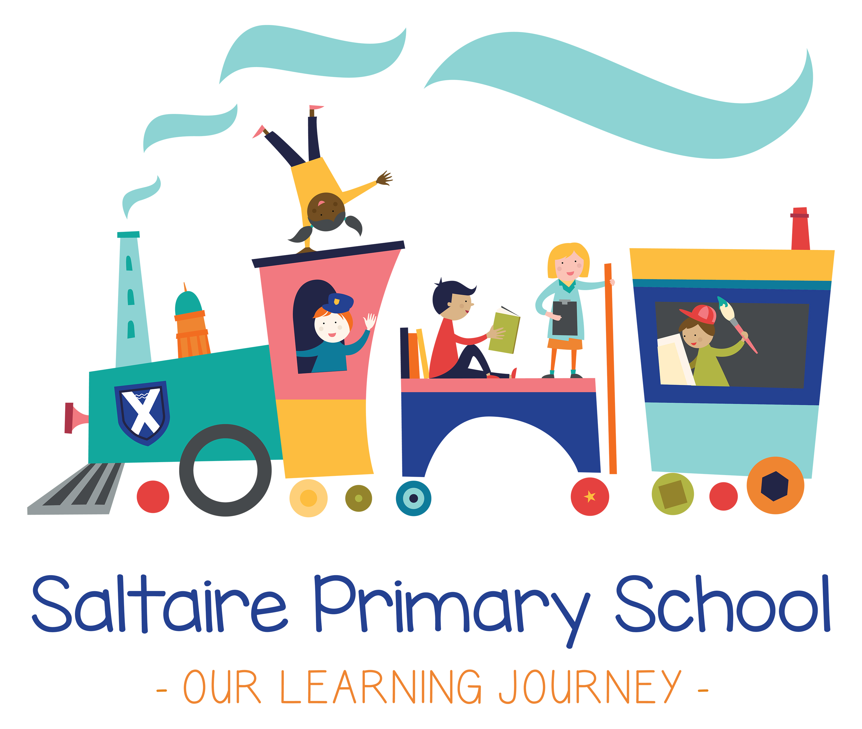

PSHE POLICY (Including sex education)

Policy Approval Date
Policy Renewal date | Spring 2016
Committee | Staffing & Curriculum
Statutory Policy | Yes
Policy on Website | Yes

Personal, Social, Health and Economic Education (PSHE) Policy;
Including Sex and Relationships Education (SRE) and Drugs education.

- Rationale:
At Saltaire Primary School our aim is to provide equality of opportunity for all in a welcoming, stimulating, happy, calm environment, which encourages high standards of achievement and behaviour and enables individuals to develop their talents and skills. We support and value all members of our school community, working as a partnership with parents/carers, governors and the wider community, to promote the life skills needed to become a valuable member of a diverse society.

Pupil Expectations
- To have the opportunity to succeed
- To celebrate everyone’s success
- To be proud of our school
- To feel valued
- To recognise that everyone in school is important
- To expect everyone to do their best
- To work as a team

- Definitions
PSHE in school reflects the school’s aims/ethos at all times. We perceive PSHE to be the physical, emotional, creative and spiritual wellbeing of each individual in a safe, caring environment where respect for themselves and others is positively encouraged. PSHE activities provide children with the opportunity to explore making safe decisions – at school, beyond school and in the wider world, including online.

Through Drugs Education pupils will be provided with opportunities to develop and appreciate the benefits of a healthy lifestyle. In creating a safe environment in school the governors do not condone the misuse or supply of legal substances such as alcohol, tobacco, medicines and solvents as well as illicit substances and will take seriously any attempt to do so. Procedures for dealing with suspicions relating to substance misuse are identified in the guidelines for this policy.

Sex and Relationships Education aims to prepare pupils for the opportunities, responsibilities and experiences of life through the development of appropriate skills and attitudes. We encourage pupils to form supportive relationships both now and as adults and feel secure about the emotional and physical changes which take place as they grow towards adolescence. The school therefore addresses sex and relationships education through its PSHE programme and the Science National Curriculum.

Citizenship enables pupils to become healthy, independent ad responsible members of society. We encourage our pupils to play a positive role in contributing to the life of the school and the wider community. In doing so, we help develop their sense of self-worth. We teach them how society is organised and governed. We ensure that they will experience the process of democracy in school through the school council. We teach them about rights and responsibilities. They learn to appreciate what it means to be a positive member of a diverse multicultural society.

E-safety education is an essential part of our school’s PSHE provision. Children and young people need the help and support of the school to recognise and avoid e-safety risks and build their resilience. E-Safety education will be provided through a planned e-safety programme as part of PHSE in the form of the Common Sense/ SWGFL Digital Literacy Scheme so that children have a clear understanding of the dangers they may face while online and their own responsibilities in keeping themselves e-safe. Pupils are taught in all lessons to be critically aware of the content they access on-line and be guided to validate the accuracy of information.

- Aims:
- To make PSHE a whole school responsibility working in collaboration with parents in the wider community.
- To provide an attractive, safe, supportive environment where concerns can be discussed, questions asked and experiences shared.
- To encourage self-esteem and self-confidence thus enabling children to take responsibility for their actions.
- To develop skills such as the sharing of feelings and opinions, risk awareness, informed decisions, getting help and understanding the needs of others.
- To provide accurate, balanced information at the appropriate level in order to keep ourselves and others safe and healthy, in school and in our wider lives, including keeping ourselves safe while using the internet.
- To provide reassurance that the physical and emotional changes which take place as pupils grow towards adolescence and adulthood are normal and acceptable.
- To provide positive role models that offer good practice, are approachable and demonstrate effective leadership skills.
- To promote a healthy lifestyle and foster the development of outside interests and leisure activities.
- To help pupils understand that they have rights and to help them keep themselves safe.
- To develop appreciation of stable, caring relationships.
- To develop an informed appreciation of other people’s beliefs, attitudes and values, also respecting others whilst challenging stereotypes.
- To develop a sense of citizenship and understanding of how society helps individuals and the contributions that individuals can make to society.
- To develop a whole school approach to PSHE with a focus on cross curricular teaching linking to key skills.
- To help children develop the ability to reflect on and become responsible for their own learning.

- Objectives
- By providing knowledge and understanding about physical, emotional, social, spiritual and creative changes that occur as pupils grow towards puberty and adulthood (see schemes of work for PSHE, Science, PE and Literacy).
- By developing an awareness of the effects of people’s actions and an acceptance of responsibility for their own actions: School Council, Buddying scheme, Play Pals, Lunchtime Monitors, office receptionists, sports leaders.
- By offering a range of learning styles and experiences using flexible group work in order to provide and practice decision making techniques and to develop problem solving and interpersonal and communication skills (refer to PSHE Schemes of Work, e-safety and Digital Literacy Schemes of Work, School Council, Literacy, Maths and Science).
- By ensuring all pupils have equal access to the whole curriculum (equal opportunities policy, PSHE policy and SEN policy).
- By acknowledging behaviour, academic and social achievement through a reward system, including valuing contributions and praising achievements (Behaviour Policy, Awards, Merits and Certificates, Achievement Assemblies, displays of children’s works, ongoing praise from staff and work of the Learning Mentor).
- By providing information about how the body works and the effects on it of harmful activities and substances, with due regard to health and safety (see schemes of work for PSHE, Science, PE, School Nurse, NHS).
- By having a shared understanding of values and how staff will foster an understanding of this for the pupils (see schemes of work for PSHE, RE, Literacy, Citizenship, Assemblies, e-safety).
- By providing pastoral support to pupils and appropriate liaison with parents and other outside agencies (Workshops for staff/governors/parents use of school nurse, Learning Mentor).
- By creating opportunities for pupils to talk to others and reflect on their own attitudes and values of those of others (see schemes of work for PSHE, RE, Literacy, Circle Time).
- By identifying named people to oversee aspects of PSHE policy (PSHE Co-ordinator).
- By offering role models that value caring relationships and healthy lifestyles.
- By identifying and meeting the professional needs of all staff with a shared understanding about appropriate confidentiality.
- By involving all appropriate staff in the production and dissemination of the PSHE Policy
- By encouraging parental involvement, e.g. Share Learning, including the provision of workshops on curriculum issues to encourage understanding and support (see Home School Diaries, School Prospectus, Home/School Agreement, Consultation Evenings and Year Group Newsletter).

- Policy, Leadership and Management
Role of Key Staff:

- PHSCE Co-Ordinator
- responsible for the day-to-day management and co-ordination of monitoring and assessment of PSHE policy.
- supporting colleagues teaching PSHE, including new members of staff and NQT’s; giving them information about specific developments and updating the subject.
- co-ordinating outside speakers/wider agencies.
- providing a strategic lead and direction for PSHE throughout the life of the school.
- developing cross curricular opportunities – contributing to the development of Early Years to Key Stage 1 and Key Stage 1 to Key Stage 2 transition strategy.
- Head teacher
- responsible for the overall co-ordination and development of PSHE particularly to monitoring serious incidents.
- Other teaching staff
- responsible for delivering every part of the PSHE curriculum and also ensuring there is a PSHE dimension to all aspects of their teaching. Furthermore, identifying and referring those children who require specific PSHE needs, particularly in terms of social and emotional well-being.
- All other staff (e.g. lunchtime supervisors, learning support staff)
- need to have an understanding and awareness of PSHE and promote the aims of the policy through their particular work.

- Monitoring and Evaluation
Monitoring is a continuous process that should take place throughout teaching to ensure that sound implementation of PSHE is taking place.

Key Issues for monitoring and evaluation in PSHE:
- Monitoring and evaluation should be seen as a continuous process that informs curriculum development and planning. It will take place at different levels within school such as:
(i) In the classroom: with individual teachers monitoring and evaluating progress in line with the learning outcomes identified for the unit. With early years teachers continuing to monitor the attainment in PSED within the foundation stage profile. Early Years practitioners to continue contributing to and evaluating a smooth transition between foundation stage 2 and key stage 1.
(ii) At a curriculum management level: with PSHE Co-ordinator and curriculum managers monitoring the progress of the different aspects of the PSHE programme and evaluating their impact on children throughout the life of the school (through lesson observations, student conferencing, work samples and assessment data).
(iii) Governors and the wider school community: being encouraged to contribute to the PSHE policy review process (every 2/3 years) as well as provide feedback, which should be logged, on PSHE throughout the school year.

- Teaching and Learning Strategies
PSHE is taught through a combination of:
- Specially time-tabled lessons (mainly KS2). Single sex may be appropriate for some aspects of sex/relationships education.
- As an integral part of other subject areas.
- School activities and events.

The school is committed to maintaining a supportive environment for its pupils and to encouraging positive and trusting relationships between adults and children and children and children.

Teaching and Learning is most effective when it is participative and active, children are encouraged to take part in a range of tasks that promote active citizenship.

The following strategies may be used:

- Assemblies
- Active learning (discussion, listening to views of others, exploration); problem solving activities.
- Setting ground rules for PSHE lessons
- Circle time
- Distancing techniques (e.g. drama, role play, case studies, puppets, quizzes)

Promoting a Healthy Lifestyle including food and physical activity
To ensure that all aspects of school life promote the health and wellbeing of pupils, staff and visitors, the school will:
- Review the formal curriculum annually to ensure information relating to all aspects of Healthy Schools is consistent and up to date
- Work with the schools caterer to promote healthy eating choices, e.g. lunchtimes, breakfast clubs
- Establish a healthy lifestyle event in school to promote all aspects of health and well being
- Promote after school clubs including sporting activities etc.
- Ensure that the tuck shop has a variety of healthy snacks and drinks available, e.g. water, fruit juice
- Provide free healthy snacks for Foundation and Key Stage 1 children.
- Support healthy eating and drinking throughout the school day
- Acknowledge that staff and other adults are influential role models for pupils and should demonstrate appropriate interactions, adult to adult and adult to child, as well as demonstrating healthy choices in front of children.

- Sex and Relationship Education in the Curriculum
Sex and Relationships Education is supported by the school’s wider curriculum for PSHE. At primary level it should:
- Develop confidence in talking, listening and thinking about feelings and relationships
- Provide information about the names of parts of the body and describe how the body works
- Prepare young people for puberty
- Develop the skills and attitudes to enable young people to protect themselves and ask for help and support

National Curriculum Science
Key Stage 1
- that animals including humans, move, feed, grow, use their senses and reproduce
- to recognise and compare the main external parts of the bodies of humans
- that humans and animals can reproduce offspring and these grow into adults
- to recognise similarities and differences between themselves and others and treat others with sensitivity

Key Stage 2
- that the life processes common to humans and other animals include nutrition, growth and reproduction
- about the main stages of the human life cycle

Complaints Procedure/Right to Withdraw
Parents can choose to withdraw their children from all or part of sex education where it is provided outside the statutory programmes of study within the National Curriculum. If a parent wishes their child to be withdrawn they should discuss this with the Headteacher and make it clear which aspects of the programme they do not want their child to participate in. It may be necessary to make parents aware of the implications of removing their child e.g. how it may make them feel and how it may affect their relationships with other children.

Drugs Education in the Curriculum
Drug education is delivered through well-planned PSHE and Citizenship provision; non-statutory guidance and the statutory requirements within the National Curriculum.

Primary Schools
At KS1 pupils learn about being safe with medicines and household substances and the basic skills for making healthy choices and following safety rules

At KS2 pupils learn about the effects and risks of alcohol, tobacco and other substances ad illegal drugs and basic skills to manage risky situations. They learn how to make informed choices about their health, how to resist pressure to do wrong and to take more responsibility of their actions.

- E-Safety and Digital Literacy

The school has a separate policy providing detailed information about our approach to e-safety and the Digital Literacy programme.

- Signatures:

Date policy formally approved by Governors: April 2016

Date policy becomes effective: April 2016

Review Date(s): April 2017

