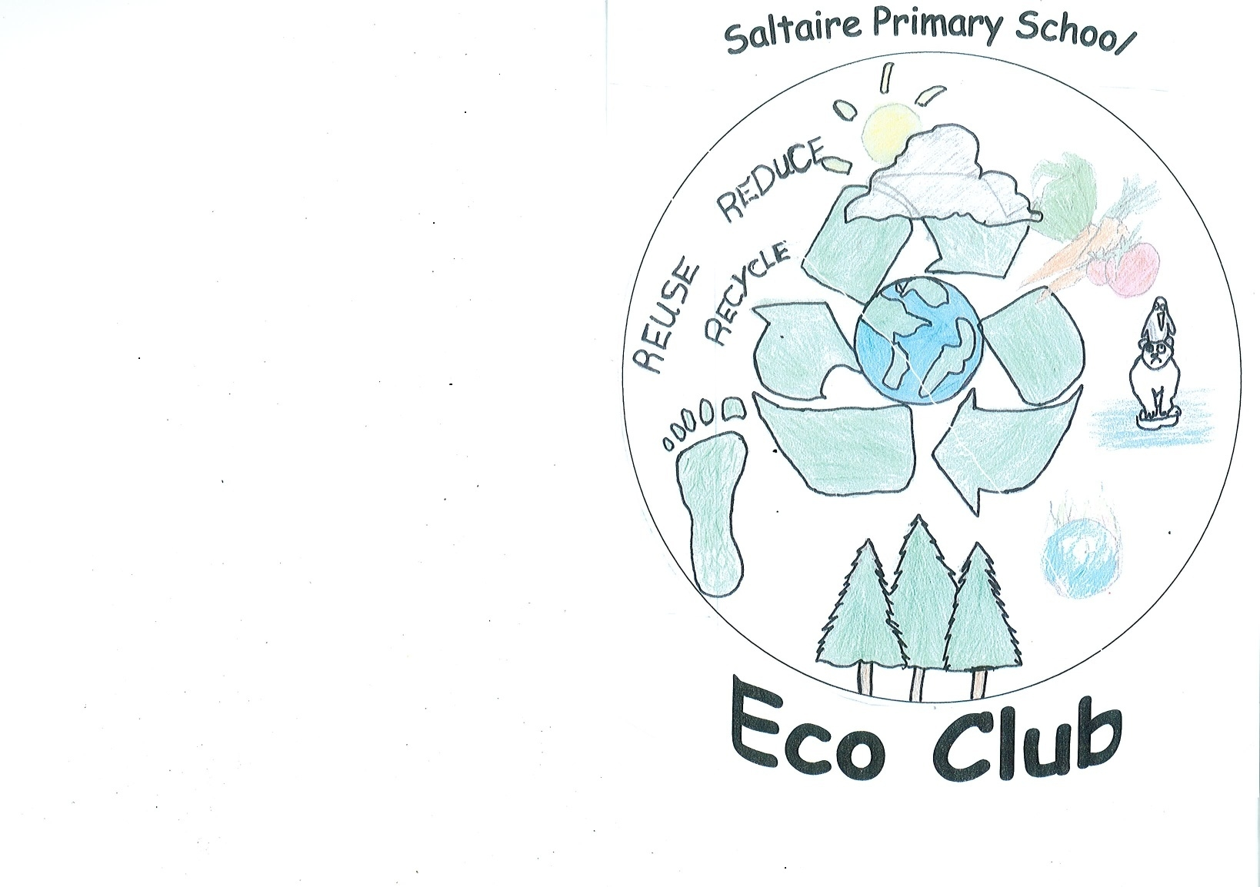
Our Eco Code
ave energy and water by switching off
lways recycle used paper
ove growing sustainable food
ake care of our school environment
ll in this together!
nspire others to follow our code
educe, Reuse and Recycle
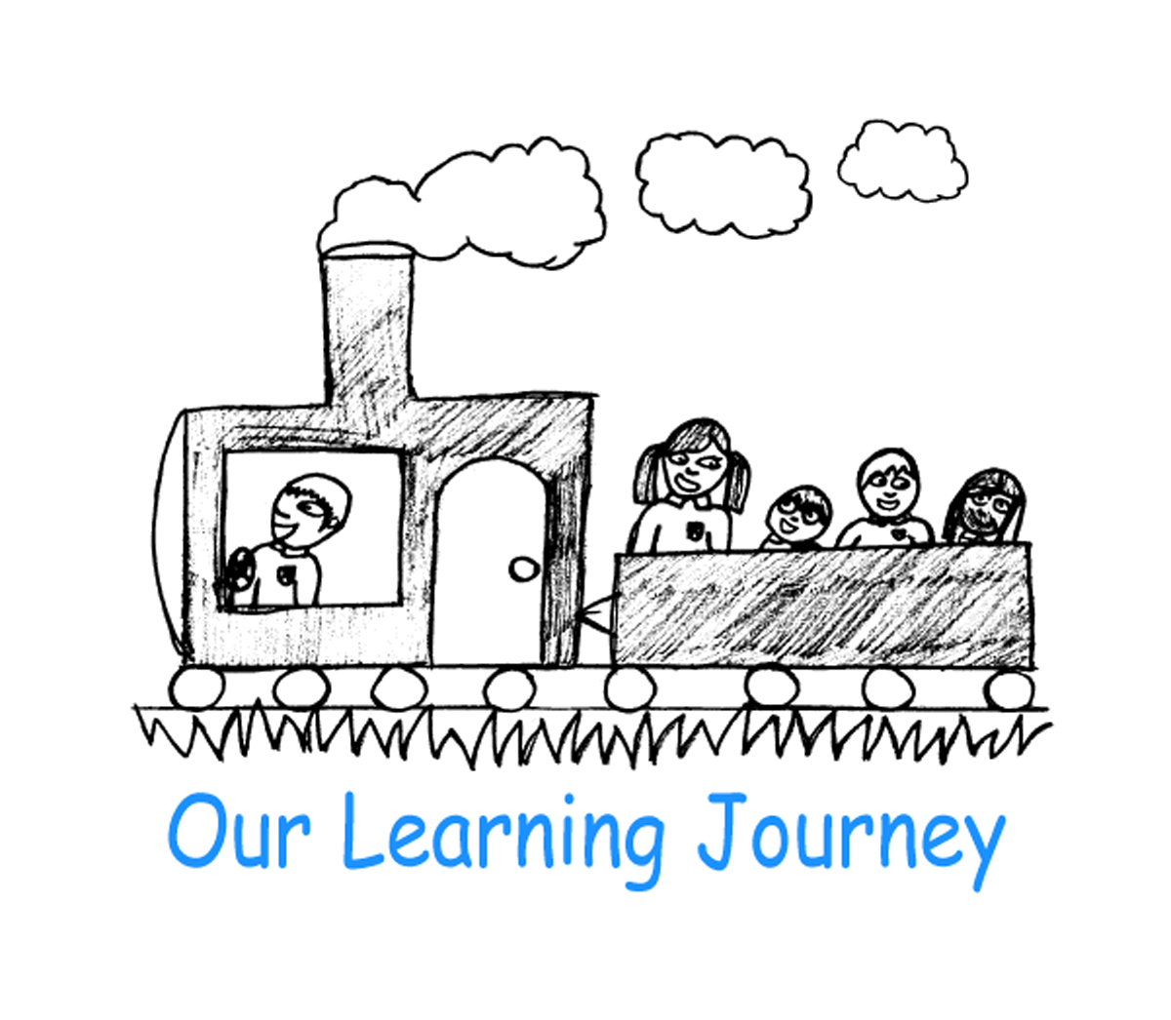
njoy being green and having fun



Our Energy Saving Tips…
This morning our Eco Club presented an assembly about energy and how we can use less at school and home.
Today we have started our ‘Goodbye Standby’ campaign in school. We hope you can make a difference at home too with our top tips. Happy energy saving!

- Use energy-efficient light bulbs
- Walk, cycle or use public transport rather than a car, whenever possible
- Use rechargeable batteries
- Wash clothes using lower water temperatures – switch machines to 30 degrees
- Shut curtains
- Avoid draughts – block gaps under doors
- Don’t overfill the kettle – only boil as much water as you need
- Make sure washing machines and dishwashers are full before running them
- Put lids on saucepans when boiling water
- Take a quick shower rather than a bath
- Turn your heating down by a few degrees
- Dry clothes on washing lines and racks, rather than in a tumble dryer
- Don’t put wet towels or clothes on radiators – it stops the heat getting out
- Unplug phone chargers when you have finished charging
- Make sure new appliances are energy-efficient
- Make sure buildings are well insulated

