Saltaire Primary

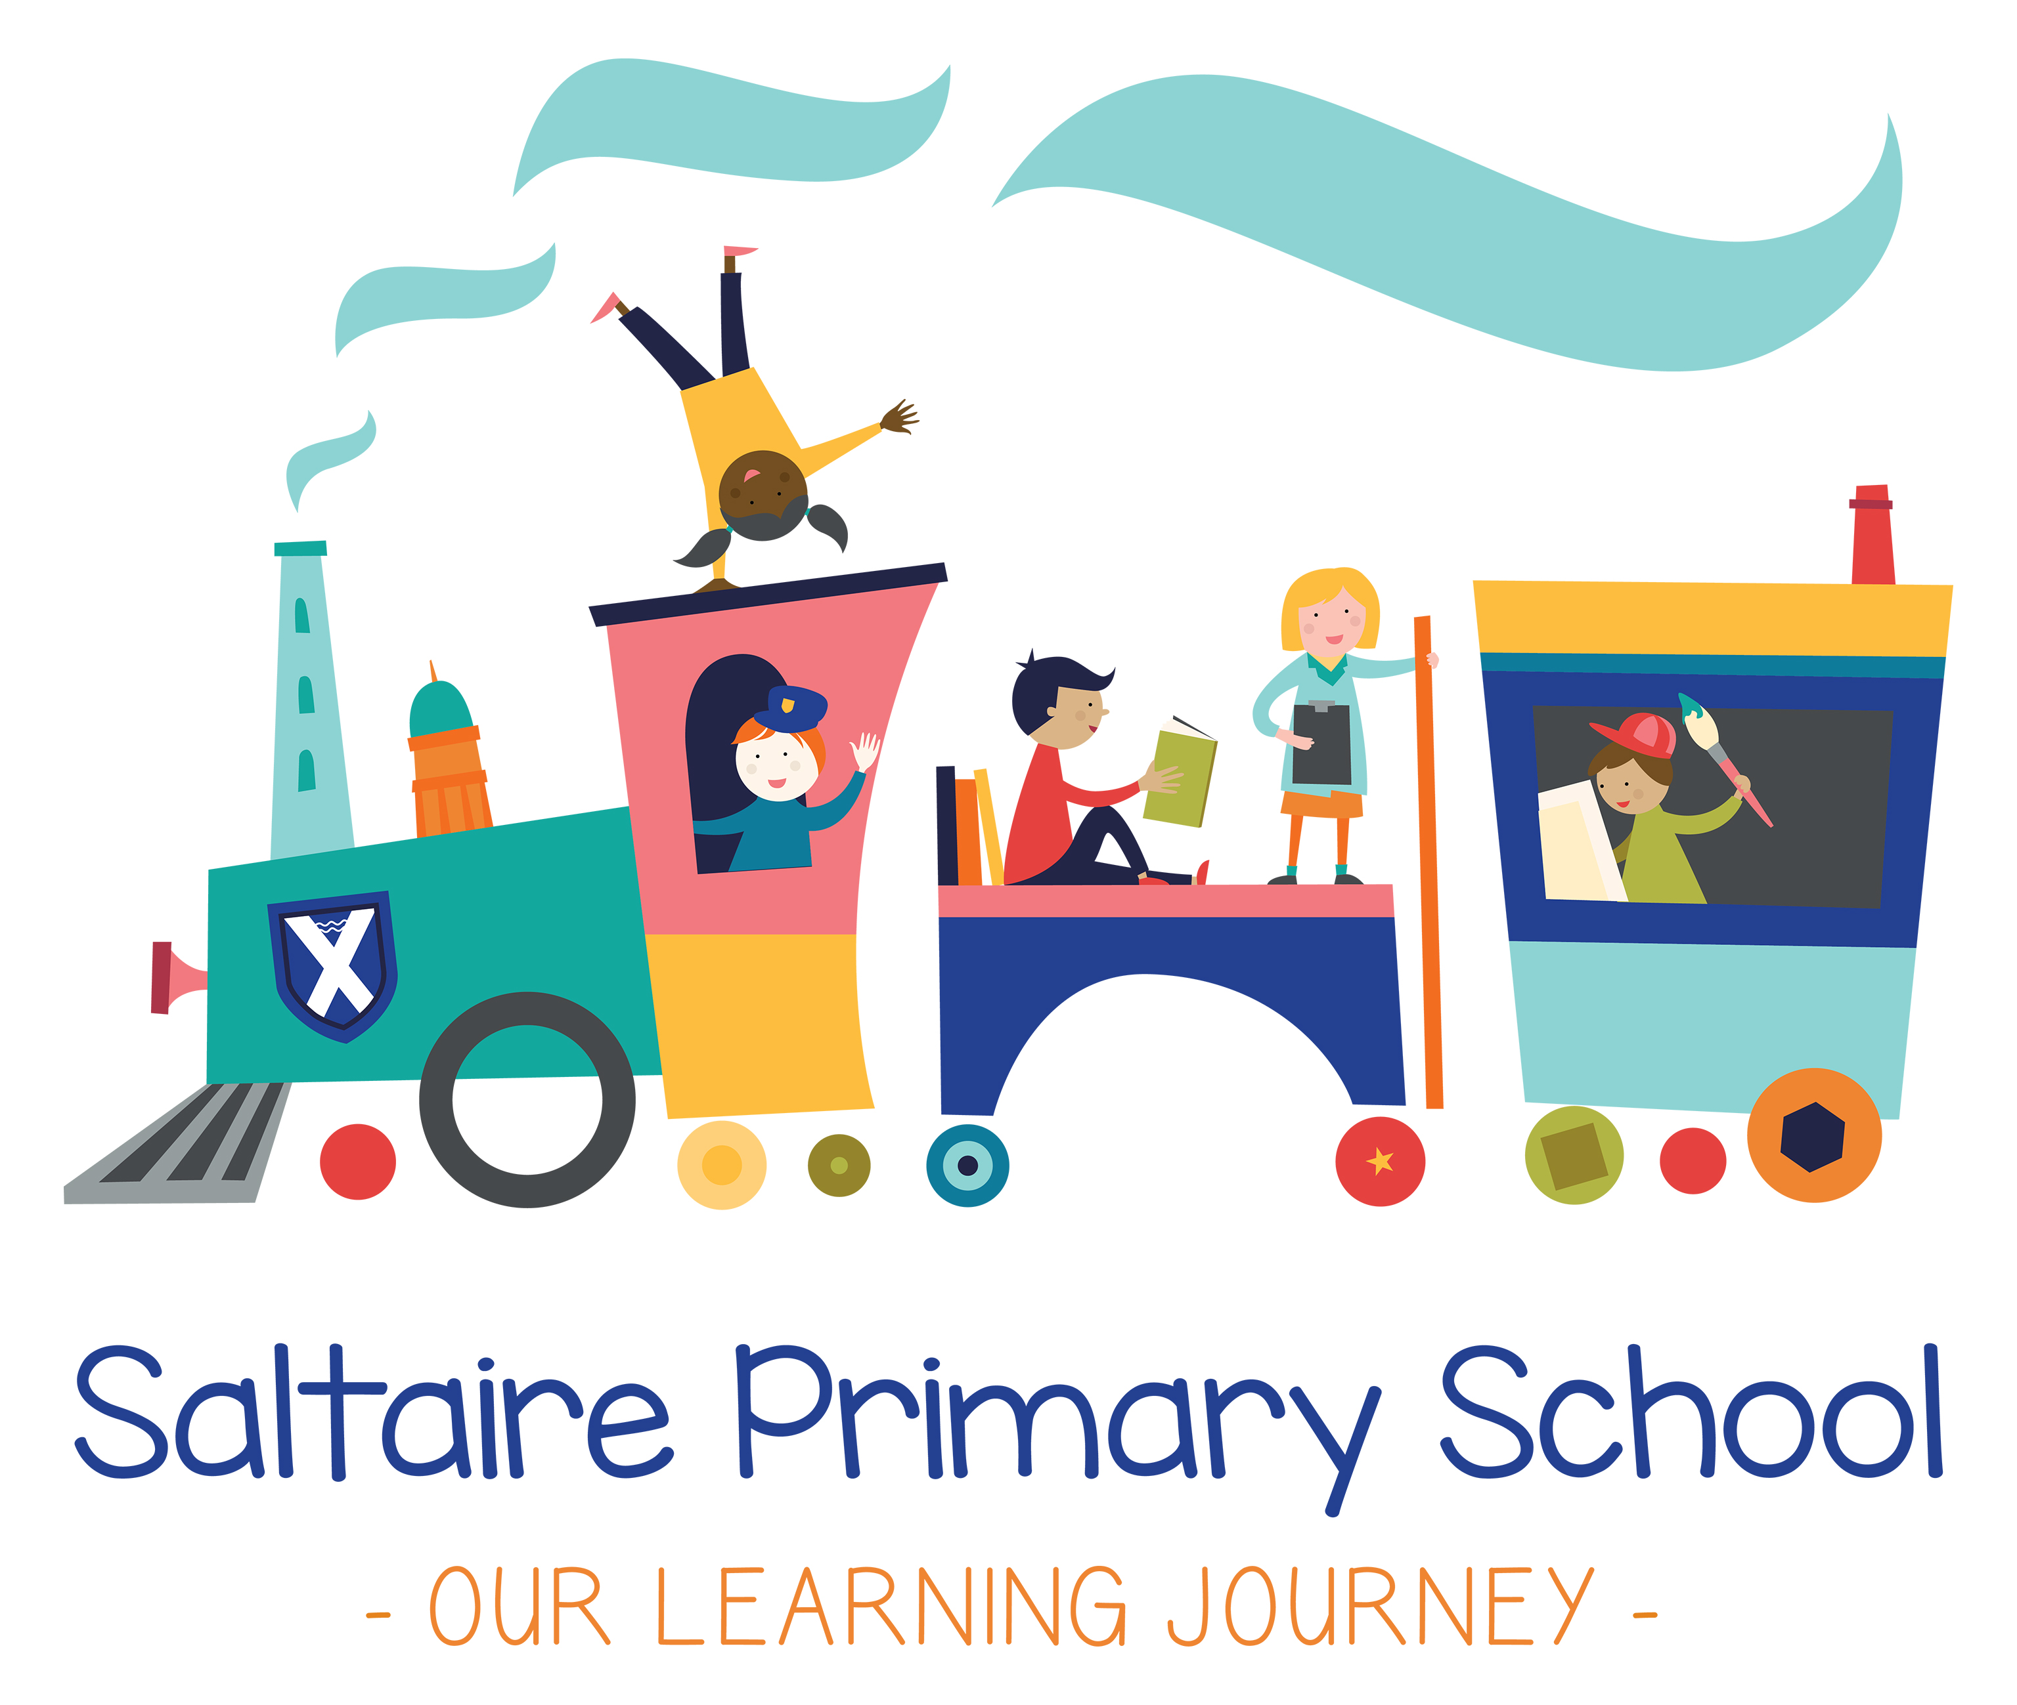

BEHAVIOUR POLICY

Policy Approval Date | February 2019
Policy Renewal date | June 2021
Committee | Teaching and Learning
Statutory Policy | Yes
Policy on Website | Yes

Contents
1. Aims 3
2. Legislation and statutory requirements 3
3. Definitions 3
4. Bullying 4
5. Roles and responsibilities 5
6. Pupil code of conduct 6
7. Rewards and sanctions 6
8. Behaviour management 7
9. Pupil transition 9
10. Monitoring arrangements…………………………………………………………………………………………………… 9
11. Links with other policies 9
Appendix 1: Written statement of behaviour principles 10
Appendix 2: Good behaviour strategy 12
Appendix 3: Rewards………………………………………………………………………………………………………………..13
Appendix 4: Good behaviour guide…………………………………………………………………………………………..14

Introduction

Saltaire Primary School is a wonderful place of learning, at the heart of a diverse community, in a unique and historic setting. We are incredibly proud to serve our community and to provide exciting and meaningful learning experiences for our children. Behaviour at Saltaire Primary School is inseparable from academic achievement, safety, welfare and wellbeing, and all other aspects of learning.

‘Behaviour’ means any actions performed by children and staff including their conduct in classrooms and around school, how children work, communicate, how they play; how they study; how they interact with each other and with staff; how they arrive at school, transition from one activity to another, and many other aspects of school life. Children and staff at Saltaire Primary School are guided by three golden rules:

We are RESPECTFUL

We are RESPONSIBLE

We are REFLECTIVE

This supports the values which weave through all we do:

We expect everyone to do their best

Everyone in our school is important and included

We recognise everyone’s uniqueness.

We are a safe school

We are proud of our school and the community we serve

We recognise that in order for children to learn effectively and make excellent progress, there must be a calm and orderly environment in which to work. We ensure that staff and children have consistently high expectations for behaviour at all times, based on the principle that all children matter equally. We believe that through the consistent application of this policy by all members of staff, every child can have a secure learning journey and successfully achieve.

1. Aims
This policy aims to:
- Provide a consistent approach to behaviour management
- Define what we consider to be unacceptable behaviour, including bullying
- Outline how pupils are expected to behave
- Summarise the roles and responsibilities of different people in the school community with regards to behaviour management
- Outline our system of rewards and sanctions

2. Legislation and statutory requirements
This policy is based on advice from the Department for Education (DfE) on:
- Behaviour and discipline in schools
- Searching, screening and confiscation at school
- The Equality Act 2010
- Use of reasonable force in schools
- Supporting pupils with medical conditions at school
It is also based on the special educational needs and disability (SEND) code of practice.
In addition, this policy is based on:
- Section 175 of the Education Act 2002, which outlines a school’s duty to safeguard and promote the welfare of its pupils
- Sections 88-94 of the Education and Inspections Act 2006, which require schools to regulate pupils’ behaviour and publish a behaviour policy and written statement of behaviour principles, and give schools the authority to confiscate pupils’ property

3. Definitions
Misbehaviour is defined as:
- Disruption in lessons, in communal areas between lessons, in assemblies and at playtime and lunchtimes
- Non-completion of classwork or homework
- Negative attitudes to learning
- Incorrect uniform
Serious misbehaviour is defined as:
- Repeated breaches of the code of conduct
- Any form of bullying
- Vandalism
- Theft
- Fighting
- Racist, sexist, homophobic or discriminatory behaviour
- Possession of an item a staff member reasonably suspects has been used to, or is likely to cause personal injury to, or damage to the property of, any person (including the child).

4. Bullying
Bullying is defined as the repetitive, intentional harming of one person or group by another person or group, where the relationship involves an imbalance of power.
Bullying is, therefore:
- Deliberately hurtful
- Repeated, often over a period of time
- Difficult to defend against

Bullying can include:

Type of bullying | Definition
Emotional | Being unfriendly, excluding, tormenting
Physical | Hitting, kicking, pushing, taking another’s belongings, any use of violence
Racial | Racial taunts, graffiti, gestures
Sexual | Explicit sexual remarks, display of sexual material, sexual gestures, unwanted physical attention, or inappropriate touching
Direct or indirect verbal | Name-calling, sarcasm, spreading rumours, teasing
Cyber-bullying | Bullying that takes place online, such as through social networking sites, messaging apps or gaming sites

Everyone in school has a responsibility to stand up to bullying. If a child or parent needs to report an incident of bullying they should tell the class teacher without delay. Any member of staff can and should report incidents of bullying via CPOMS and inform a senior member of staff.

Saltaire Primary School will take the following action:
- Respond straight away
- Investigate all alleged bullying incidents, including cyber-bullying
- Reassure victims and offer help and support
- Make it clear to someone found to be bullying that their behaviour is not acceptable
- Encourage a child who has been found to bully to see the victim’s point of view
- Explain the consequences of their action and steps taken
- Record all bullying incidents and alleged bullying incidents as such
- Be watchful and proactive, discussing potential problems through individual, group and circle time sessions
- Inform and involve the parents/carers of both the perpetrator and the victim

5. Roles and responsibilities

5.1 The governing body
The governing body is responsible for reviewing and approving the written statement of behaviour principles (appendix 1).
The governing body will also review this behaviour policy in conjunction with the headteacher and monitor the policy’s effectiveness, holding the headteacher to account for its implementation.

5.2 The headteacher
The headteacher is responsible for reviewing this behaviour policy in conjunction with the governing body, giving due consideration to the school’s statement of behaviour principles (appendix 1). The headteacher will also approve this policy.
The headteacher will ensure that the school environment encourages positive behaviour and that staff deal effectively with poor behaviour and will monitor how staff implement this policy to ensure rewards and sanctions are applied consistently.

5.3 Staff
Staff are responsible for:
- Implementing the behaviour policy consistently
- Modelling positive behaviour
- Providing a personalised approach to the specific behavioural needs of particular pupils
- Recording behaviour incidents using CPOMS
The senior leadership team will support staff in responding to behaviour incidents.

5.4 Parents
Parents are expected to:
- Support their child in adhering to the school code of conduct
- Inform the school of any changes in circumstances that may affect their child’s behaviour
- Discuss any behavioural concerns with the class teacher promptly

6. Our Golden Rules

At Saltaire Primary School, we have established three golden rules which we promote to ensure that all children understand their responsibilities as part of our school community. These are:

We are RESPECTFUL

We are RESPONSIBLE

We are REFLECTIVE

In practise, these are condensed down into three words – RESPECT, RESPONSIBILITY, REFLECTION – and promoted visually around the building and through activities such as assembly and PSHE lessons. We give children lots of opportunities to discuss the meaning of these words and to develop an understanding of the many different ways in which they can be demonstrated.

7. Rewards and sanctions
At Saltaire Primary School, we use praise and positive reinforcement to reward good behaviour. When children demonstrate positive attitudes to learning, this is acknowledged against the Champion Learning criteria. We are careful to use praise meaningfully so that children are clear about what they are being praised for.

7.1 List of rewards and sanctions
Positive behaviour will be rewarded with:
- Praise, including the use of marble jars to reward individuals as part of a team or class
- Merit awards, stickers and wristbands
- Letters, postcards or phone calls home to parents
- Special responsibilities/privileges

Teachers may also choose to introduce bespoke rewards according to the age of the children in their class. These should be in keeping with the expectations of the school so should be discussed with a Leader of Learning or the Headteacher prior to implementation.

The school may use one or more of the following sanctions in response to unacceptable behaviour:
- A verbal warning
- Expecting work to be completed at playtime or lunchtime
- PDR session – Personal Development and Reflection time
- Referring the pupil to a senior member of staff
- Letters or phone calls home to parents

See appendix 2 – Our Good Behaviour Strategy

7.2 Off-site behaviour
Sanctions may be applied where a child has misbehaved off-site when representing the school, such as on an educational visit. We take the safety of our children seriously, including making sure they stay safe online. If we are made aware of any online safety concern, including cyberbullying, we will deal with this in the same way as we would any other incident of bullying.

7.3 Malicious allegations
Where a pupil makes an accusation against a member of staff and that accusation is shown to have been malicious, the headteacher will discipline the pupil in accordance with this policy.
Please refer to our Safeguarding and Child Protection Policy for more information on responding to allegations of abuse.
The headteacher will also consider the pastoral needs of staff accused of misconduct.

8. Behaviour management

8.1 Classroom management
Teaching and support staff are responsible for setting the tone and context for positive behaviour within the classroom.
They will:
- Create and maintain a stimulating environment that encourages pupils to be engaged
- Display the golden rules prominently in their classroom, referring to them in supporting high expectations for behaviour and learning
- Develop a positive relationship with pupils, which may include:
  - Greeting pupils in the morning/at the start of lessons
  - Establishing clear routines
  - Communicating expectations of behaviour in ways other than verbally
  - Highlighting and promoting good behaviour
  - Concluding the day positively and starting the next day afresh
  - Having a plan for dealing with low-level disruption
  - Using positive reinforcement

8.2 Physical restraint
In some circumstances, staff may use reasonable force to restrain a pupil to prevent them:
- Causing disorder
- Hurting themselves or others
- Damaging property
Incidents of physical restraint must:
- Always be used as a last resort
- Be applied using the minimum amount of force and for the minimum amount of time possible
- Be used in a way that maintains the safety and dignity of all concerned
- Never be used as a form of punishment
- Be recorded using CPOMS and reported to parents

8.3 Confiscation
If a child brings to school an item which could have the potential to cause harm to another person, the item will be removed from them. These items will not be returned to pupils.
We will also remove any item which may disrupt lessons or lead to inappropriate behaviour. These items will be returned to pupils after discussion with senior leaders and parents, if appropriate.
Searching and screening pupils is conducted in line with the DfE’s latest guidance on searching, screening and confiscation.

  - Pupil support
The school recognises its legal duty under the Equality Act 2010 to prevent pupils with a protected characteristic from being at a disadvantage. Consequently, our approach to challenging behaviour may be differentiated to cater to the needs of the pupil.
Our Assistant Headteacher for inclusion will evaluate a pupil who exhibits challenging behaviour to determine whether they have any underlying needs that are not currently being met.
Where necessary, support and advice will also be sought from specialist teachers, an educational psychologist, medical practitioners and/or others, to identify or support specific needs.
When acute needs are identified in a pupil, we will liaise with external agencies and plan support programmes for that child. We will work with parents to create the plan and review it on a regular basis.

9. Pupil transition
To ensure a smooth transition to the next year, pupils have transition sessions with their new teacher(s). In addition, staff members hold transition meetings.
To ensure behaviour is continually monitored and the right support is in place, information related to pupil behaviour issues may be transferred to relevant staff at the start of the term or year. Information on behaviour issues may also be shared with new settings for those pupils transferring to other schools.

10. Monitoring arrangements
This behaviour policy will be reviewed by the headteacher and full governing body every three years. At each review, the policy will be approved by the headteacher.
The written statement of behaviour principles (appendix 1) will be reviewed and approved by the full governing body every three years.

11. Links with other policies
This behaviour policy is linked to the following policies:
- Exclusions policy
- Safeguarding and Child Protection policy
- Online Safety Policy

Appendix 1: written statement of behaviour principles

Champion Learning
To support our children in developing positive attitudes to learning, we have agreed four Champion Learning behaviours so they can experience success and become lifelong learners.

Concentrate  Successful people work hard, giving their full attention to whatever it is they are doing. We encourage children to have fun while focusing their attention on the content of the curriculum and the things that interest them. We encourage children to see having fun and concentration as one and the same thing. | Cooperate  Successful people work well with others and understand that other people in the team may work or think differently. They communicate in a way that helps others to understand. Our curriculum helps children to realise that collaboration is what the real world is all about. Community harmony is all about cooperation and understanding each other.
Create  Successful people have lots of ideas. They use their imagination and are prepared to be wrong. Our curriculum provides children with lots of opportunities to use their imagination, which is the keystone to creativity. We make sure our school curriculum gives lots of opportunity for children to try new things so that they are motivated in their learning, recognising that people can be creative in many different ways. | Challenge  Successful people need to push themselves. When they experience setbacks and difficulty, they find ways to bounce back and try again. Our curriculum is engaging and relevant so that children see the point of what they are doing. It provides children with opportunities to take risks and challenge themselves in a safe environment.

Statement of Behaviour Principles

- Every pupil understands they have the right to feel safe, valued and respected, and learn free from the disruption of others
- All pupils, staff and visitors are free from any form of discrimination
- Staff and volunteers set an excellent example to pupils at all times
- Rewards, sanctions and reasonable force are used consistently by staff, in line with the behaviour policy
- The behaviour policy is understood by pupils and staff
- The exclusions policy explains that exclusions will only be used as a last resort, and outlines the processes involved in permanent and fixed-term exclusions
- Pupils are helped to take responsibility for their actions
- Families are involved in behaviour incidents to foster good relationships between the school and pupils’ home life

The governing board also emphasises that violence or threatening behaviour will not be tolerated in any circumstances.
This written statement of behaviour principles is reviewed and approved by the full governing body every three years.

Appendix 2: Good Behaviour Strategy

If the Golden Rules are not followed, this is what will happen:
Stage 2
- You will be moved to sit somewhere else to prevent further disruption. In the playground, you will have a short time out in some suitable area so that the teacher on duty has clear vision of you, or you may walk around with a member of staff.
- If there is another incident you will miss playtime and go to PDR
- After 3 PDR sessions within a half term, a behaviour letter will be sent home

Stage 1
- You will be reminded about the Golden Rules and how you can improve your learning and behaviour
- If there is another incident you will be advised again of the Golden Rules and how to improve or move to the next stage

Stage 3
- If 3 behaviour letters are given in one half term you will be referred to the Headteacher and parents contacted as appropriate.
In Reception
If the behaviour persists you will be referred to the Headteacher and parents contacted as appropriate.

Stage 4
- If the behaviour persists the Headteacher will make further contact with your parents and a personal support programme will be prepared to help your behaviour improve

Appendix 3: Good Behaviour Guide

The following pages provide guidance on the behaviour we promote when children are involved in different aspects of school life. This helps adults and children to understand their roles.

